downl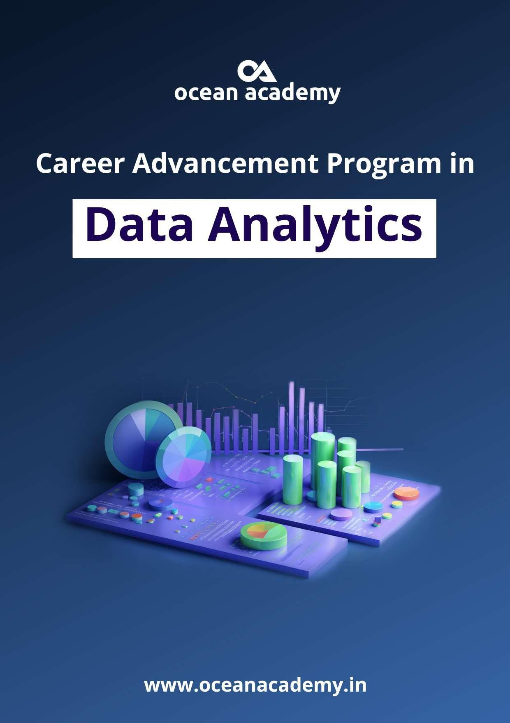

**Data Analyst - syllabus**

**Python Programming:**

* Introduction
* Conditional statements
* Looping
* Control statements
* String manipulation
* Lists
* Tuple
* Dictionary
* Functions
* Modules
* File Handling
* Exceptional Handling
* Git & GitHub

**Data Manipulation using numpy:**

* Introduction to NumPy
* Creation of Array & Array Operations
* Array Creation Functions – identity, ones, zeros, full
* Array indexing and slicing
* Array Looping
* Array Sorting
* Numpy Methods & Attributes
* Copy and View
* Arange & Reshape
* Join, Split, Stack
* Arithmetic & Matrix Operations using array
* Boolean operations and Filtering
* Random module
* Array Statistical Functions
* Array Mathematical Functions



**Data Manipulation using Pandas:**

* Introduction to pandas
* Pandas Data Structures
* Series Operations
* DataFrame Operations
* Indexing, loc and iloc
* Data Loading and Summary Statistics
* Datatype conversion
* Missing Value Treatment
* Data Manipulation
  + Add/remove – (.assign(), .drop() )
  + Renaming columns and Indexes – (.rename() )
  + Sorting (.sort_values() & sort_index() )
  + Filtering Data
  + Merging, Joining, Concatenating Data
* Creating New Columns
* Outliers, Skewness and Kurtosis
* Merging, Joining, Concatenating Data
* Group by, Reshaping and Pivot Tables
* Data Visualization with pandas

**Data visualization using Matplotlib:**

* Introduction to Matplotlib
* Basic Statistical Terms and Correlation
* Difference between Univariate, Bi-variate, Multivariate
* Setting Graph figure size
* Creating Basic Plots
  + Line Plot
  + Scatter Plot
  + Bar Plot
  + Histogram Plot
  + Pie Chart
* Customizing Plots
  + Titles and Labels
  + Legend
  + Ticks and grids
  + Lines and Markers
* Subplots

**Data visualization using Seaborn:**

* Introduction to Seaborn
* Import Library
* **Distribution Plot**
* **Univariate:**
  + Displot (Distribution Plot)
  + rug Plot
  + kde Plot
* **Bivariate:**
  + Scatter Plot
  + reg Plot
  + resid Plot
  + kde Plot
  + hex
* **Multivariate:**
  + Pairplot
* **Categorical Plot**
* **Univariate:**
* Factor Plot
* Box Plot
* violinplot
* stripplot
* swarmplot
* Barplot
* countplot
* **Bivariate:**
  + Violin Plot
  + Strip & swarm plot
* **Grid Plot**
* **Bivariate:**
  + Pair grid &Plot
  + Facet grid
* **Multivariate:**
  + Join Plot
* **Matrix Plot**
* **Multivariate:**
* Heat plot
* **Regression plot**



**Exploratory Data Analysis:**

* Introduction to EDA
* Loading Data
* Data Inspection
* Descriptive Statistics
* Handling Missing Values
* Data Types and Conversion
* Feature Engineering
* Outlier Deduction and Treatment
* Data Visualization
  + Univariate, Bi-variate, multivariate
* Scaling and Transformation
* Key Finding and Business Insights

**Mathematics and stats:**

* Introduction to Statistics
* Descriptive Statistics
* Inferential Statistics
* Probability & Distributions
* Bayes Theorem
* Normal Distribution
* Basics of Hypothesis Testing
* Scipy Library

**SQL**

* Introduction to DBMS and SQL
* Installation of MySQL
* SQL Commands
* DDL Commands
* DML Commands
* Functions
* Joins
* Sub-queries
* Windows function

**Excel Basic to Advanced:**

* Introduction to MS-Excel
* Data Import and Export
* Tabs and Ribbons
* Add, Edit and Delete Data
* Formatting
* Data Cleaning
* Formulas and Functions
* Pivot Table
* Charts and Graphs
* Keyboard Shortcuts
* Automation and Macros
* Dashboard Building

**Tableau:**

* Introduction to Tableau
* Connecting to Data Sources
* Understanding Data Types and Roles
* Data Preparation
* Data Cleaning
* Data Blending
* Joins and Unions
* Basic Visualizations
  + Creating Bar Charts
  + Creating Line Charts
  + Creating Pie Charts
  + Creating Scatter Plots
* Creating Geographic Maps
* Customizing Maps
* Calculations
  + Basic Calculations
  + Table Calculations
  + Filters and Parameters
    - Applying Filters
    - Using Parameters
* Sorting and Grouping
* Grouping and Creating Sets
* Dashboards and Stories
  + Creating Dashboards
  + Adding Interactivity
  + Creating Stories
* Formatting and Design
  + Formatting Visualizations
  + Customizing Tooltips
  + Themes and Styles
* Publishing and Sharing
  + Publishing to Tableau Public/Tableau Server
  + Sharing Workbooks and Dashboard

